TQS: Quality Assurance manual

***Grupo 105***

v0000-00-00

1.1 Team and roles 1

1.2 Agile backlog management and work assignment 1

2.1 Guidelines for contributors (coding style) 2

2.2 Code quality metric 2

2.3 Git Standards 2

3.1 Development workflow 3

3.2 CI/CD pipeline and tools 3

3.3 Artifacts repository [Optional] 3

1.1 Overall strategy for testing 3

1. Functional testing/acceptance 4

2. Unit tests 4

3. System and integration testing 4

4. Performance testing [Optional] 4

# Project management

## Team and roles

**Team manager**: Tomás Costa

**DevOps master**: João Marques

**Product owner**: Francisco Jesus

**Developer**: Everyone

**Backend:** João Marques, Francisco Jesus

**Frontend:** Tomás Costa, Miguel Matos

## Agile backlog management and work assignment

For backlog management we are using GitLab Boards and Milestones, assigning each task to a specific developer. We are experiencing GitLab instead of Jira, to expand our technology stack, and see how well it works.

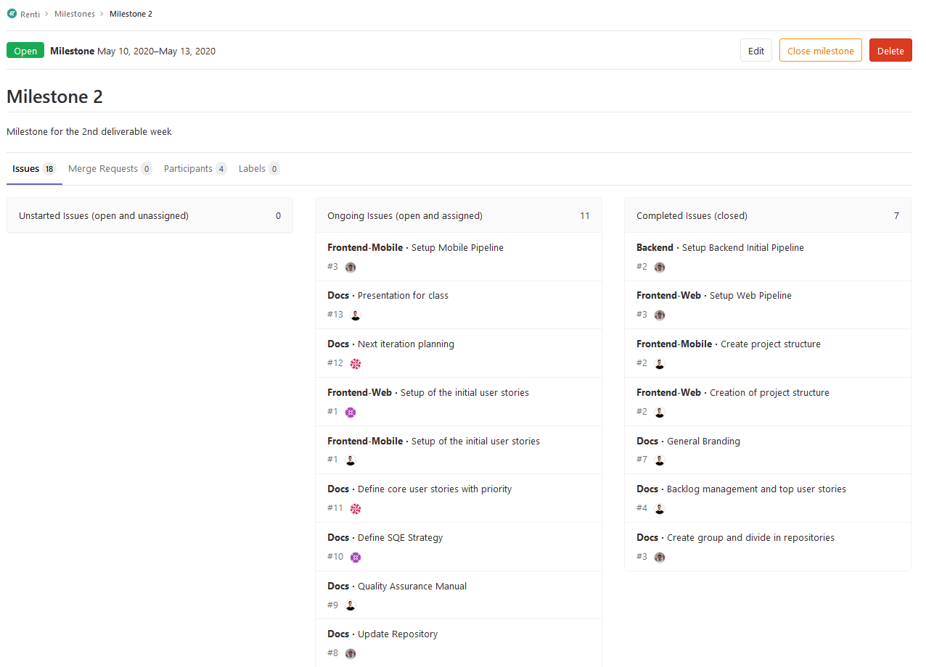

# Code quality management

## Guidelines for contributors (coding style)

Still a work in progress, but heavily inspired in [AOS project](https://source.android.com/source/code-style.html) with standards like:

* + Dont ignore exceptions
  + Dont catch generic exceptions
  + Defining fields in standard places
  + Using TODO Comments
  + Logging instead of printing
  + Using standard bracket style

Also some standards from “[Clean Code](https://www.amazon.com/Clean-Code-Handbook-Software-Craftsmanship/dp/0132350882)”:

* + Avoid duplication anywhere in code
  + [Law of Demeter](https://dzone.com/articles/the-genius-of-the-law-of-demeter)

## Code quality metric

[Description of practices defined in the project for *static code analysis* and associated resources.]

[Which quality gates were defined? What was the r[ationale?]

Still a work in progress, check [link](https://www.perforce.com/blog/sca/what-static-analysis).

Expected use of SonarQube for static code analysis, due to past experience.

We are also integrating Static Code Analysis with the GitLab CI pipeline by using a **Code Quality** [template script provided by GitLab](https://docs.gitlab.com/ee/user/project/merge_requests/code_quality.html).

## Git Standards

GitLab was the obvious choice for the Git Platform since it has easier CI/CD Integration and our backlog management, which allows us to close tasks in commits. Some standards are:

* + Never merge directly, always make pull requests and identify at least one person to check (review) that pull request before merging the PR. (All repositories are configured to not accept a single person merge)
  + **New feature branch:** For each new feature create a branch following the standard: feature/<feature_name>.
  + **New Issue branch:** For each fix create a branch following the standard: fix/<fix-name>.
  + Closing issues/tasks can be done by writing in commit message: “this closes #<issue_nr>”

# Continuous delivery pipeline (CI/CD)

## Development workflow

[Clarify the workflow adopted [e.g.. [gitflow](https://www.atlassian.com/git/tutorials/comparing-workflows/gitflow-workflow) workflow, [github flow](https://guides.github.com/introduction/flow/) . How do they map to the user stories?]

[Description of the practices defined in the project for *code review* and associated resources.]

[What is your team “[Definition of done](https://medium.com/@anca_51481/user-story-definition-of-done-dod-in-agile-software-development-and-the-technical-debt-a3abf6821ef2)” for a user story?]

We decided to adopt a standard Git Flow, which resides on the following:

1. Map each user story into one (or more) system feature(s).
2. Map each feature into a git branch.
3. Classify the feature as done when the expected system behavior is accomplished.
4. Merge the feature branch into the master/production branch.

## CI/CD pipeline and tools

[Description of the practices defined in the project for the continuous integration of increments and associated resources. Provide details on the tools setup and config.]

[Description of practices for continuous delivery, likely to be based on *containers*]

As in previous projects, we implemented a CI/CD workflow using Gitlab.

On each commit made to the code repository, a pipeline is triggered. This pipeline is resposible for conducting the previously mentioned code quality static analysis, and produce the respective report, as well as conductiong tests, building the source code into packages, and continuously deploying the services.

## Artifacts repository [Optional]

[Description of the practices defined in the project for local management of Maven *artifacts* and associated resources. E.g.: a[rtifactory](https://www.jfrog.com/artifactory/)]

The software elements are packaged into **docker containers**, used both to run the services locally, and in deployment. In the Gitlab pipeline, this docker images are automatically build and uploaded to a private **container registry**, making them accessible for our group and for the deployment environment.

# Software testing

* 1. Overall strategy for testing

## Overall strategy for testing

Still a work in progress, check “Clean Code” chapters for testing and these links:

* + [Strategies](https://www.tutorialride.com/software-engineering/strategies-of-software-testing.htm)
  + [Testing overview](https://www.tatvasoft.com/blog/software-testing-quality-assurance-strategies/)

[what was the overall test development strategy? E.g.: did you do TDD? Did you choose to use Cucumber and BDD? Did you mix different testing tools, like REST-Assured and Cucumber?...]

**Three Laws of TDD**

* + You may not write production code until you have written a failing unit test.
  + You may not write more of a unit test than is sufficient to fail, and not compiling is failing.
  + You may not write more production code than is sufficient to pass the currently failing test.

## Functional testing/acceptance

[Project policy for writing functional tests (closed box, user perspective) and associated resources.]

## Unit tests

[Project policy for writing unit tests (open box, developer perspective) and associated resources.]

## System and integration testing

[Project policy for writing integration tests (open or closed box, developer perspective) and associated resources.]

API testing

## Performance testing [Optional]

[Project policy for writing performance tests and associated resources.]